1. Simpleif.java (if statement)

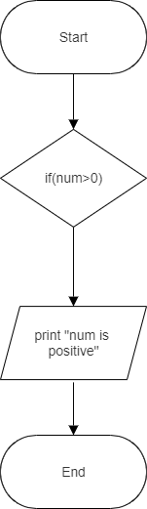

1. If-else(compare.java)

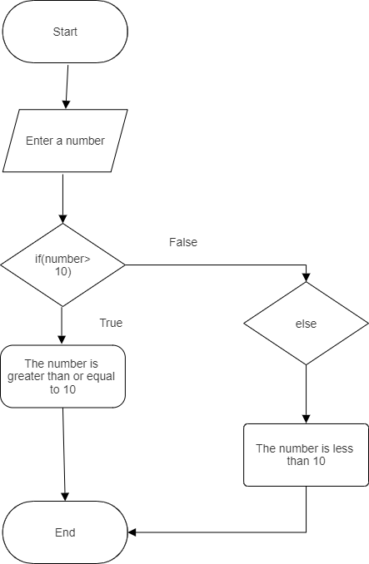

1. Nested if-else (GreatestofThree)

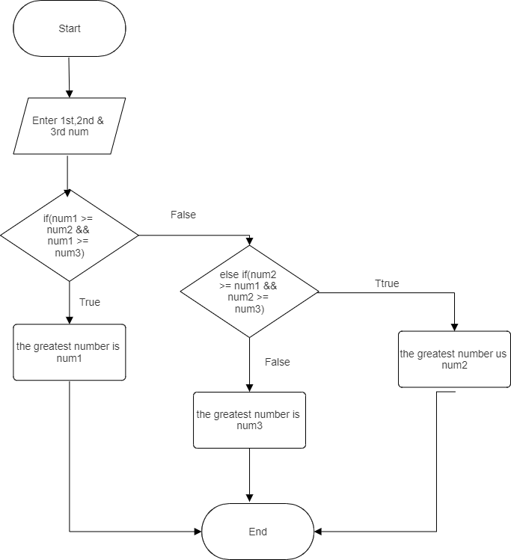

1. Switch (Calculator.java)

